Selenium WebDriver
Selenium WebDriver is the most important component of Selenium Tool's Suite. The latest release "Selenium 2.0" is integrated with WebDriver API which provides a simpler and more concise programming interface.
The following image will give you a fair understanding of Selenium components and the Test Automation Tools.
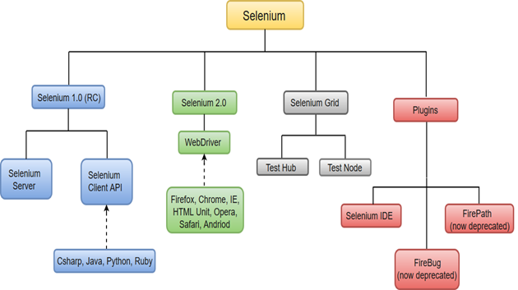
Selenium WebDriver was first introduced as a part of Selenium v2.0. The initial version of Selenium i.e Selenium v1 consisted of only IDE, RC and Grid. However, with the release of Selenium v3, RC has been deprecated and moved to legacy package.

In WebDriver, test scripts can be developed using any of the supported programming languages and can be run directly in most modern web browsers. Languages supported by WebDriver include C#, Java, Perl, PHP, Python and Ruby.
Selenium WebDriver performs much faster as compared to Selenium RC because it makes direct calls to the web browsers. RC on the other hand needs an RC server to interact with the browser.

WebDriver has a built-in implementation of Firefox driver (Gecko Driver). For other browsers, you need to plug-in their browser specific drivers to communicate and run the test. Most commonly used WebDriver's include:
Google Chrome Driver
Internet Explorer Driver
Opera Driver
Safari Driver
HTML Unit Driver (a special headless driver)

Selenium WebDriver- Architecture
Selenium WebDriver API provides communication facility between languages and browsers.
The following image shows the architectural representation of Selenium WebDriver.
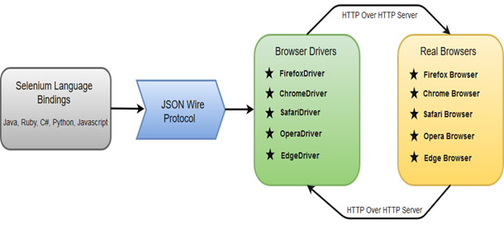
There are four basic components of WebDriver Architecture:
- Selenium Language Bindings
- JSON Wire Protocol
- Browser Drivers
- Real Browsers

Selenium Language Bindings / Selenium Client Libraries
Selenium developers have built language bindings/Selenium Client Libraries in order to support multiple languages. For instance, if you want to use the browser driver in java, use the java bindings.

JSON Wire Protocol
JSON (JavaScript Object Notation) is an open standard for exchanging data on web. It supports data structures like object and array. So, it is easy to write and read data from JSON.
JSON Wire Protocol provides a transport mechanism to transfer data between a server and a client. JSON Wire Protocol serves as an industry standard for various REST web services.

Browser Drivers
Selenium uses drivers, specific to each browser in order to establish a secure connection with the browser without revealing the internal logic of browser's functionality. The browser driver is also specific to the language used for automation such as Java, C#, etc.
When we execute a test script using WebDriver, the following operations are performed internally.
- HTTP request is generated and sent to the browser driver for each Selenium command.
- The driver receives the HTTP request through HTTP server.
- HTTP Server decides all the steps to perform instructions which are executed on browser.
- Execution status is sent back to HTTP Server which is subsequently sent back to automation script.

Browsers
Browsers supported by Selenium WebDriver:
Internet Explorer
Mozilla Firefox
Google Chrome
Safari

Selenium WebDriver- Features
Some of the most important features of Selenium WebDriver are:
- Multiple Browser Support: Selenium WebDriver supports a diverse range of web browsers such as Firefox, Chrome, Internet Explorer, Opera and many more. It also supports some of the non-conventional or rare browsers like HTMLUnit.
- Multiple Languages Support: WebDriver also supports most of the commonly used programming languages like Java, C#, JavaScript, PHP, Ruby, Pearl and Python. Thus, the user can choose any one of the supported programming language based on his/her competency and start building the test scripts.
- Speed: WebDriver performs faster as compared to other tools of Selenium Suite. Unlike RC, it doesn't require any intermediate server to communicate with the browser; rather the tool directly communicates with the browser.
- Simple Commands: Most of the commands used in Selenium WebDriver are easy to implement. For instance, to launch a browser in WebDriver following commands are used:
WebDriver driver = new FirefoxDriver(); (Firefox browser )
WebDriver driver = new ChromeDriver(); (Chrome browser)
WebDriver driver = new InternetExplorerDriver(); (Internet Explorer browser)
- WebDriver- Methods and Classes: WebDriver provides multiple solutions to cope with some potential challenges in automation testing.
WebDriver also allows testers to deal with complex types of web elements such as checkboxes, dropdowns and alerts through dynamic finders.
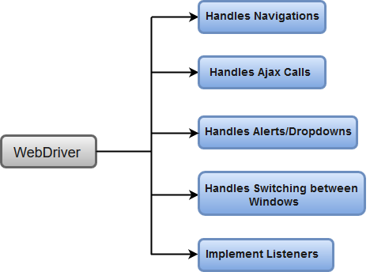

Installation of Selenium
1. Java should be installed
2. Install Eclipse
3. Install Chrome and chrome driver (Version should be same)
https://chromedriver.chromium.org/downloadsDownload
4. selenium Jar(Stable java version) and include it in build path of project
https://www.selenium.dev/downloads/
OR Create a Maven project with selenium dependency
https://mvnrepository.com/artifact/org.seleniumhq.selenium/selenium-java
<dependency>
<groupId>org.seleniumhq.selenium</groupId>
<artifactId>selenium-java</artifactId>
<version>3.141.59</version>
</dependency>

Note: Remember to delete chromedriver.exe from task manager(if getting any error)

